REQUIREMENT ANALYSIS

MODULE 2 – DATA FLOW DIAGRAM & USER STORIES
Date : | 27.09.2026
Team ID : | SWTID-2026-9496
Project Name : | Streamlining IT Procurement: Automating Standard Laptop Orders with Flow Designer
Maximum Marks | 4 Marks

Data Flow Diagram (DFD)
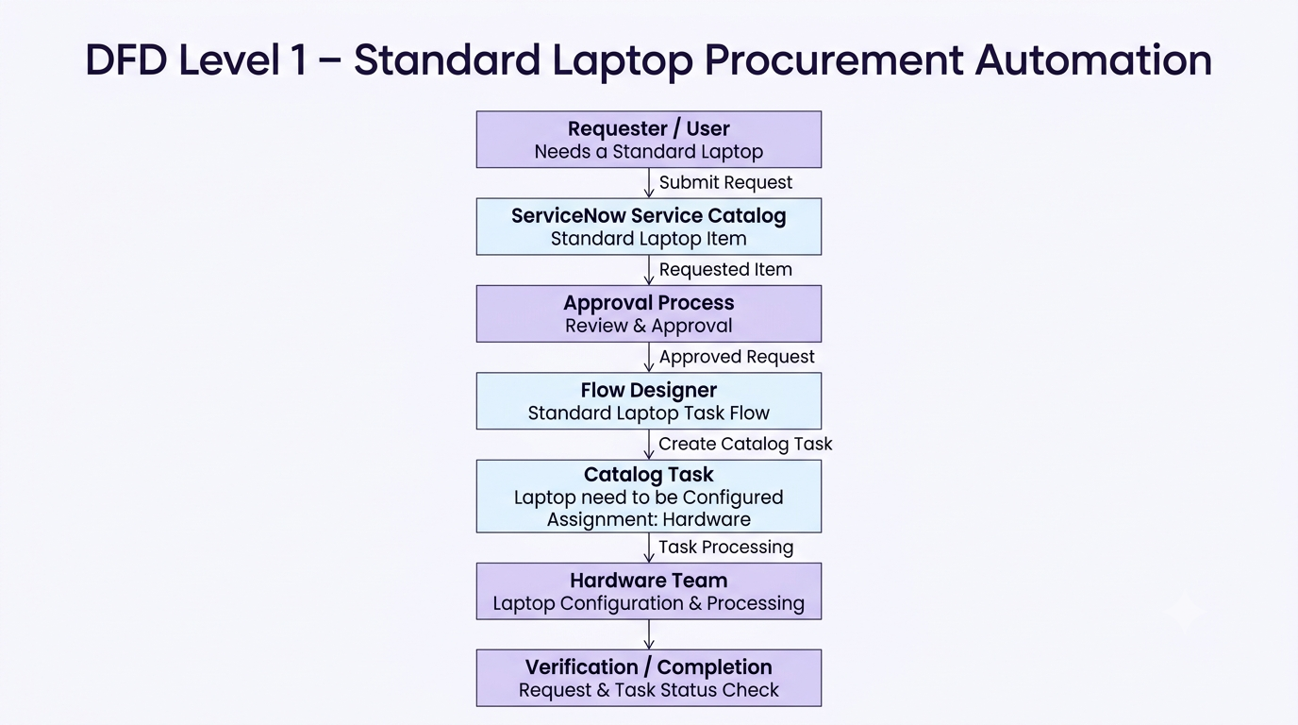
Flow Explanation
1. Standard Laptop Request:
The requester accesses the ServiceNow Service Catalog and selects the Standard Laptop Catalog Item.
2. Request Submission:
The requester enters the required information and submits the laptop request. A Requested Item is created in ServiceNow.
3. Approval:
The request is reviewed through the approval process. Once the request is approved, it proceeds to the next stage.
4. Flow Designer Processing:
The Standard Laptop Task Flow Designer flow is triggered for the approved request. The flow automates the creation of the required Catalog Task.
5. Catalog Task Creation:
A Catalog Task is automatically created with the required task details and assigned to the Hardware Assignment Group.
6. Hardware Processing:
The Hardware team receives the task and performs the required laptop configuration and processing.
7. Verification & Completion:
The task and Requested Item are checked to verify that the task was created correctly, assigned to Hardware, and processed successfully.
User Stories
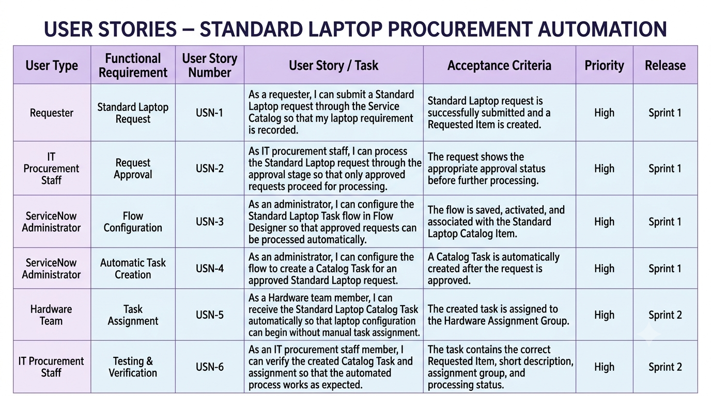

Data Flow Summary
The Data Flow Diagram represents the movement of a Standard Laptop request from submission through approval, automated task creation, Hardware assignment, and final verification. Flow Designer acts as the main automation component, reducing the need for manual Catalog Task creation and assignment.

Requirement Analysis Summary
The requirement analysis identifies the main users, system interactions, functional requirements, and expected outcomes of the Standard Laptop procurement automation. The DFD shows how information moves through the ServiceNow Service Catalog, approval process, Flow Designer, Catalog Task, and Hardware team, while the user stories define the expected system behavior and acceptance criteria.

